**Reg No: RA2111032010006**

**Name: Shaurya Singh Srinet**

**Branch: CSE w/s in IoT**

**Class: T2**

Object Oriented Design and Programming

Assignment: Week-2:

1. Write a C++ program to print whether the given number is positive number or negative number.

#include <iostream>

using namespace std;

int main()

{

float n1;

cout<<"Enter a number to check if it is positive or negative: ";

cin>>n1;

if(n1>0)

cout<<n1<<" is positive";

else

cout<<n1<<" is negative";

return 0;

}

Input and Output:

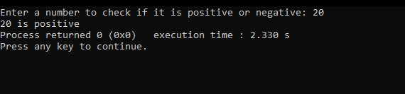

1. Write C++ program to find if an integer is positive, negative or zero //using nested if statements

#include <iostream>

using namespace std;

int main()

{

float n1;

cout<<"Enter a number to check if it is positive, negative or zero: ";

cin>>n1;

if(n1>=0)

{

if(n1==0)

cout<<n1<<" is zero";

else

cout<<n1<<" is positive";

}

else

cout<<n1<<" is negative";

return 0;

}

Input and output:

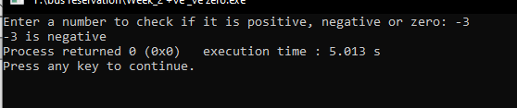

1. C++ Program to Count Total Number of Notes Using If Else Statement.

#include <iostream>

using namespace std;

int main()

{

int n1,a,b,c,d,e,f,g,h,i,j;

cout<<"Enter the amount: ";

cin>>n1;

a=n1/2000;

b=(n1%2000)/500;

c=((n1%2000)%500)/200;

d=(((n1%2000)%500)%200)/100;

e=((((n1%2000)%500)%200)%100)/50;

f=(((((n1%2000)%500)%200)%100)%50)/20;

g=((((((n1%2000)%500)%200)%100)%50)%20)/10;

h=(((((((n1%2000)%500)%200)%100)%50)%20)%10)/5;

i=((((((((n1%2000)%500)%200)%100)%50)%20)%10)%5)/2;

j=(((((((((n1%2000)%500)%200)%100)%50)%20)%10)%5)%2)/1;

cout<<"Total number of notes: -\n2000 = "<<a<<"\n500 = "<<b<<"\n200 = "<<c<<"\n100 = "<<d<<"\n50 = "<<e<<"\n20 = "<<f<<"\n10 = "<<g<<"\n5 = "<<h<<"\n2 = "<<i<<"\n1 = "<<j;

return 0;

}

Input and Output:

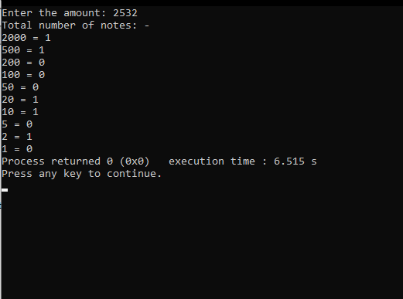

1. Write a program to create a Calculator using the switch Statement.

#include <iostream>

using namespace std;

int main()

{

char o;

int n1,n2;

cout<<"Enter the first number: ";

cin>>n1;

cout<<"Enter the second number: ";

cin>>n2;

cout<<"Enter the operator you want to perform\nAddition: +\nSubtraction: -\nMultiplication: *\nDivision: /\nModulus: %\n";

cin>>o;

switch (o)

{

case '+':

cout<<"The addition is "<< n1+n2;

break;

case '-':

if(n1>n2)

cout<<"The subtraction is "<<n1-n2;

else

cout<<"The subtraction is "<<n2-n1;

break;

case '*':

cout<<"The multiplication is "<<n1*n2;

break;

case '/':

cout<<"The division is "<<n1/n2;

break;

case '%':

cout<<"The modulus is "<<n1%n2;

break;

default:

cout<<"Invalid Operator";

break;

}

return 0;

}

Input and Output:

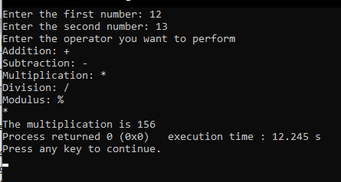

12. Write a program to find factorial of a given number using Recursion

#include<iostream>

using namespace std;

int main()

{

int fact,n,i;

fact=1;

cout<<"Enter any number: ";

cin>>n;

for(i=1;i<=n;i++)

{

fact = fact*i;

}

cout<<"Factorial of "<<n<<" is "<<fact;

return 0;

}

Input and Output:

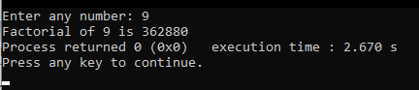

**Arrays, Strings and functions**

1. Write a C++ program to find the largest element of a given array of integers

#include <iostream>

using namespace std;

int main() {

int i,n,a[100];

cout<<"Enter how many numbers you want to compare: ";

cin>>n;

cout<<"Enter the numbers: -\n";

for(i=0;i<n;++i)

cin>>a[i];

for(i=1;i<n;++i)

if(a[0]<a[i])

a[0]=a[i];

cout<<"Largest element = "<<a[0];

return 0;

}

Input and Output:

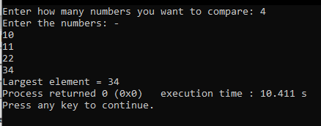

9. Write a simple C++ program to get string input array of fruit names and display it using for-loop.

#include <iostream>

using namespace std;

int main()

{

string s[100];

int i,n;

cout<<"Enter the number of fruits you want to enter: ";

cin>>n;

cout<<"Enter the fruit names: -\n";

for(i=0;i<n;i++)

cin>>s[i];

cout<<"The fruits are: -\n";

for(i=0;i<n;i++)

cout<<s[i]<<endl;

return 0;

}

Input and Output:

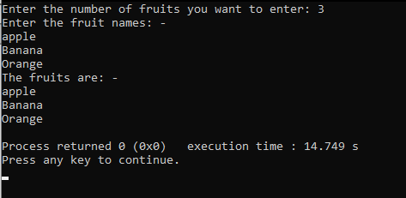

**Structures, Unions and Files**

1. Write a C program to store information of n students using structure

#include<iostream>

using namespace std;

struct student

{

char idno[15];

char name[20];

char course[20];

char sec[5];

}s[1000];

int main()

{

int i,n;

cout<<"Enter number of students: ";

cin>>n;

cout<<"Enter the information of the students: \n";

for(i=0;i<n;i++)

{

cout<<"Student: "<<i+1;

cout<<"\n\nEnter ID No: ";

cin>>s[i].idno;

cout<<"Enter Name: ";

cin>>s[i].name;

cout<<"Enter Course: ";

cin>>s[i].course;

cout<<"Enter Section: ";

cin>>s[i].sec;

cout<<endl;

}

}

Input and Output:

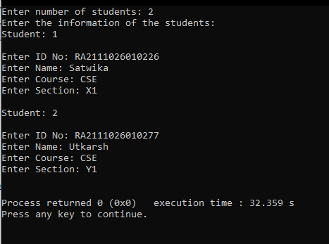

1. Write a C program to append content to a file.

#include<iostream>

#include<string>

#include<fstream>

using namespace std;

int main()

{

fstream f;

ofstream fout;

ifstream fin;

int i;

char a[30];

fin.open("abc.txt");

fout.open ("abc.txt",ios::app);

if(fin.is_open())

cout<<"Enter the data: ";

cin>>a[i];

fout<<a[i];

cout<<"\n Data has been appended to file"<<endl;

fin.close();

fout.close();

string word;

f.open("abc.txt");

while (f >> word) {

cout << word << " ";

}

return 0;

}

Input and Output

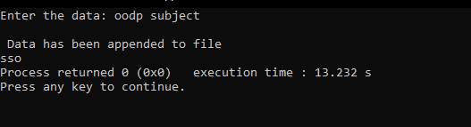

1. Write a C program to add two distances in feet and inches using structure

#include <iostream>

using namespace std;

struct Distance {

int feet;

float inch;

}d1 , d2, sum;

int main()

{

cout << "Enter 1st distance," << endl;

cout << "Enter feet: ";

cin >> d1.feet;

cout << "Enter inch: ";

cin >> d1.inch;

cout << "\nEnter information for 2nd distance" << endl;

cout << "Enter feet: ";

cin >> d2.feet;

cout << "Enter inch: ";

cin >> d2.inch;

sum.feet = d1.feet+d2.feet;

sum.inch = d1.inch+d2.inch;

if(sum.inch > 12)

{

int extra = sum.inch / 12;

sum.feet += extra;

sum.inch -= (extra * 12);

}

cout << endl << "Sum of distances = " << sum.feet << " feet " << sum.inch << " inches";

return 0;

}

Input and Output

